SIMPLE CHECKMATES (Part 1)

- Checkmate with Queens:
With 2 or more Queens, it is easy to checkmate. However, we have to avoid stalemate which means draw. To ensure a checkmate, we need to keep on checking.
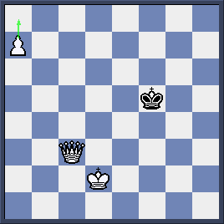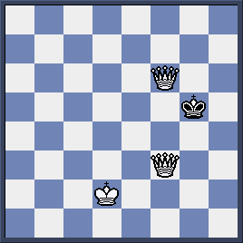
Here White wins by 1.a8Q Kf4 2.Qaf3+ Kg5 3.Qcf6 #
- Checkmate with Queen and Rook:
We have 2 ways to do it: linear check and square check

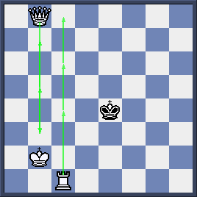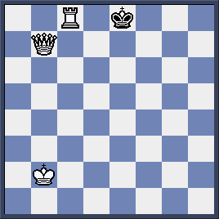
White makes sure that Black King will be pushed down the back rank by
- Qb3 Kd4 2.Rc4+ Ke5 3.Qb5+ Kd6 4.Rc6+ Kd7 5.Qb7+ Ke8 6.Rc8#
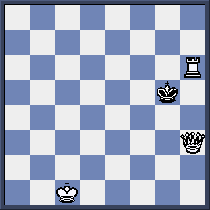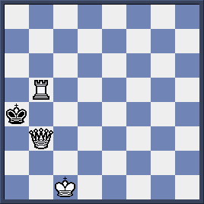
White is to win by 1. Rh5+ Kf4 2. Rf5+ Ke4 3.Qf3+ Kd4 4.Rd5+ Kc4 5.Qd3+ Kb4 6.Rb5+ Ka4 7.Qb3#

Quiz:

Black is up materially but White to move: will he resign or make a late comeback?

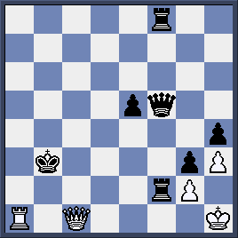

- Checkmate with 2 Rooks:
We can again use linear check. Each rook will take turn to control files or ranks to force opposing King to the edge of the board where he is mated.
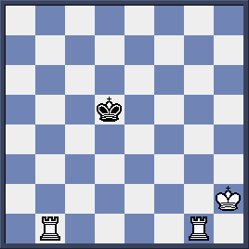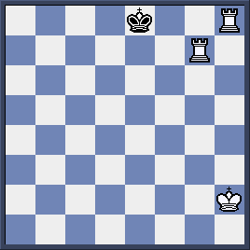

Linear check: 1.Rb5+ Kc6 2.Rh5! Kd6 3.Rg6+ Ke7 4.Rh7+ Kf8 5.Rgg7! Ke8 6.Rh8 #
Note that if 1…Kc4 2.Rh5! Kd4 3.Rg4+ Ke3 4.Rh3+ Kf2 5.Rg2+ Kf1 6.Kg3! Ke1 7.Rh1#

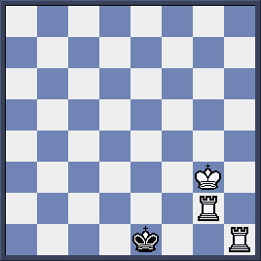

Quiz:

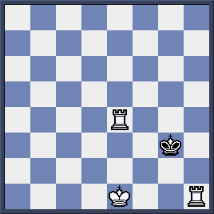
White is to play and checkmate in 2 moves.
1.-------------------
2.------------------

